Double It And Give It To The Next Person
Category: Pwn | Difficulty: Easy

Description
You start with $1. The rules are simple: double it and give it to the next person. Nobody ever breaks the chain... right?
Connect: nc <host> <port>
The download contains the binary and a fake test flag so you can build your exploit locally. The real flag only lives on the server.

Files
Players download `double_it.tar.gz` (in challenge/dist/): the double_it binary plus a placeholder flag.txt and a player README. The real service is a hosted netcat/socat endpoint — each connection forks its own process with the real flag.txt in the working directory.
Intended server deployment (binary rebuilt from source inside the image, real flag injected via $FLAG). From challenge/:
cd challenge
docker build -t double_it -f server/Dockerfile .
docker run --rm -p 1337:1337 -e FLAG='flag{...}' double_it
# players: nc <host> 1337
The build source and server files are in challenge/src/, challenge/Makefile, and challenge/server/ (the prebuilt challenge/double_it binary is included too). The reference exploit, writeups, metadata and flag are in organizer/: solve/solve.py, WRITEUP.md, README-CTFd.md, challenge.yml, flag.txt. The binary is built with -no-pie -fno-stack-protector -O0 (NX stays on) — a clean, beginner-friendly ret2win.
⚠️ Organizer note 1 — `challenge/server/Dockerfile` does not build as shipped. Two fixes are needed before deployment: (1) add `make` to the apt-get install line (currently only gcc libc6-dev socat, so RUN make fails with exit 127); and (2) remove the redundant cp double_it /chal/double_it — WORKDIR is already /chal, so make writes the binary there and the cp fails with *"are the same file."* This walkthrough was produced by serving the exact shipped challenge/double_it binary via the same socat entrypoint (so the reference exploit's hard-coded addresses match).
⚠️ Organizer note 2 — deploy this one in host:port mode, not behind the HTTPS subdomain proxy. This is a raw TCP service (nc/pwntools, binary protocol with null bytes in the payload). The Docker-CTFd reverse proxy carries HTTP(S)/WebSocket only — its own README states *"Raw TCP (nc) and UDP challenges need host:port mode."* Behind the encrypted-subdomain proxy it would be unsolvable (no HTTP Host/SNI on a bare TCP connection, and the proxy would mangle the binary payload). Set Subdomain Mode = No for this challenge so players get host:PORT and a direct TCP path to the container. Pwn services are served as plain TCP, so no SSL/TLS is applied to the socket — players connect with plain nc/pwntools and the exploit works unchanged.

Hint(s)
- How many bytes are read, and how big is the buffer they go into?
- There's a function that handles the flag but is never called. nm double_it.
- Crashes right as it shells out? That's a 16-byte stack alignment (movaps) issue — return through one extra ret gadget first.

Walkthrough
A classic ret2win: overflow the 256-byte name buffer, overwrite the saved return address with the never-called break_the_chain() (which runs system("/bin/cat flag.txt")), and insert one bare ret gadget first to fix 16-byte stack alignment for system().
- Normal behavior. The program hands you "$1", asks who started the chain, echoes your name, and fizzles out — no flag on the happy path.
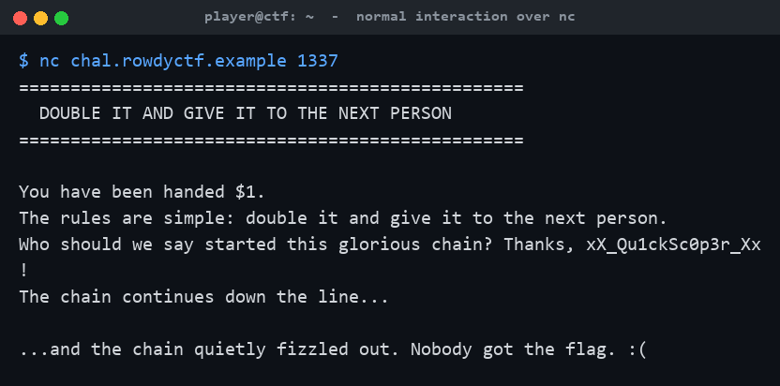
Normal interaction over nc
- Recon. checksec shows non-PIE, NX on, no stack canary. In the source, char name[256] is filled by read(0, name, 0x200) — up to 512 bytes into a 256-byte buffer, a textbook stack overflow. nm reveals an unreferenced break_the_chain() at the fixed address 0x4004c6 that cats the flag. The offset to the saved return address is 256 + 8 (saved RBP) = 264.
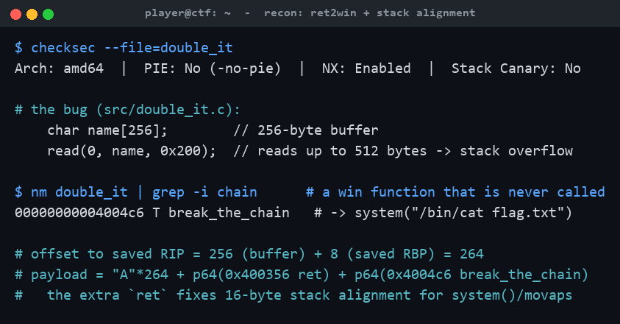
Recon: ret2win target + alignment
- Build the payload. A naive "A"*264 + p64(break_the_chain) returns with RSP misaligned, so system()'s movaps faults and crashes before the flag prints. Prepend a bare ret gadget (0x400356) to nudge RSP by 8 and realign:
```
payload = b"A"*264 + p64(0x400356) + p64(0x4004c6)
```
- Fire it at the server. The overflow redirects execution into break_the_chain(), the chain "snaps," and the server cats the real flag.txt back to you:
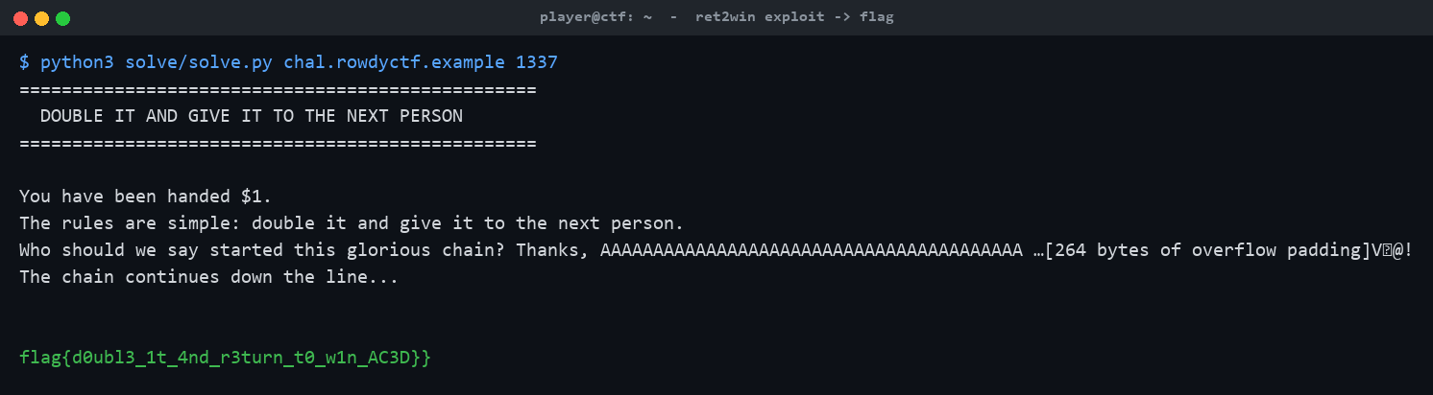
ret2win exploit returns the flag

Flag
The flag is set per-deployment via the FLAG environment variable (the handout ships only placeholder flags). In this walkthrough the server was launched with FLAG=flag{d0ubl3_1t_4nd_r3turn_t0_w1n_AC3D}, and the exploit retrieved exactly that value:
flag{d0ubl3_1t_4nd_r3turn_t0_w1n_AC3D}

